Statistical Learned Ultimate (SLU)

AF Analytics

Table of Contents
Objective 3
Data Inputs and Processing 3
Methodology 3
1. Short/ Medium/ Long tailed LoB classification 3
2. Initial Selection 3
3.Curve Fit 5
4.Determine the Factor 1 index 6
5.Final Selection 6
6.Ultimate Calculation 9
7.Ultimate Method Selection by Exposure Year 9
Appendix 1 10
Appendix 2 11

Objective

Efficient estimation of actuarial reserves using machine-based selection of development factors and appropriate reserving methods.

Data Inputs and Processing

- The analysis is done on YQ gross incurred triangle (attritional losses only) for short to medium tailed lines of business. Recent 10 exposure years of data is considered for Short tailed LoBs and 14 years of data is considered for Medium tailed LoBs from the most recent non-zero incurred year. Data older than recent 14 years from the analysis year will not be considered for analysis.
- Both incremental and cumulative triangles are needed for the analysis.
- Reserving methods’ assumptions are fetched from Vena.
This documentation contains snapshots of data/results for profile ‘Marine_Cargo_DE_CS_AY’ as at 2020 Q4 valuations.

Methodology

1. Short/ Medium/ Long tailed LoB classification
Reserve classes are classified as short, medium or long tailed based on average duration. Average duration is calculated using the payment patterns selected by reserving actuaries as at 2021 Q4 valuations.
A reserve class is classified as
- Short tailed if average duration is <=3 years
- Medium tailed if average duration >3 years and average duration <=5 years
- Long tailed if average duration >5 years

2. Initial Selection
- Initial selection is made using Volume weighted averages calculated on cumulative incurred triangle, depending on the type of business:
Short Tailed – Volume weighted 3,4 and 5 are evaluated
Medium Tailed – Volume weighted 3,4,5,6,7,8,9,10, and All are evaluated
Long Tailed – Volume weighted 5,6,7,8,9,10, and All are evaluated

- Evaluation of Volume weighted period:
Averages of different periods are then evaluated to select the optimal period for initial selected LDFs:
  - RMSE is calculated by development period among the link ratios and the initial selected factor for that period
  - Weights are given as absolute of (1-%Incurred Developed)
  - Weighted RMSE is calculated for volume weighted averages for all periods
  - The period which has the least weighted RMSE is finalized for computing initial selections

- Outlier Detection in link ratios:
For development periods with minimum of 4 data points (or link ratios), in the triangle of link ratios, we exclude factors falling outside the range
If IQR !=0, then [Q1 – 3*IQR *exp(-Skewness*abs(MC)) , Q3 + 3*IQR *exp( Skewness*MC)]
If IQR = 0 , then [0.95*Q1 , 1.05*Q3]
where Q1 and Q3 are the first and third quartiles for the development period factors and IQR is the Inter Quartile Range.
Skewness is the skewness of a distribution based on the population.
This method relies on the ‘medcouple’ (MC) statistic of skewness which allows for more data to be included where the data is skewed. Using MC, the interval for acceptable link ratios is modified and outliers are detected using the modified interval.
Note : If we don’t adjust for skewness, then the normal IQR approach for outlier detection will identify more outliers in either direction, possibly under/over estimating DFM ultimate.

Calculation of MC:

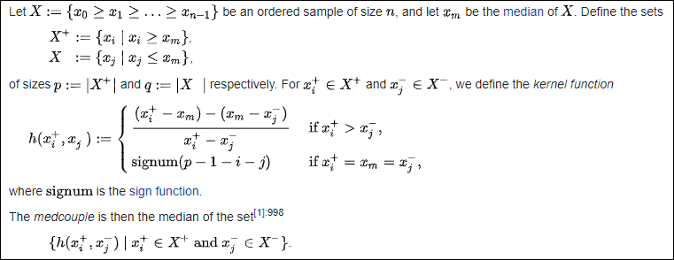

3.Curve Fit
Our objective here is to determine influential data points from initial selection of LDFs to exclude from curve fit that negatively impacts the overall fit of the curve
- From the initial selection, each development factor is removed one by one and the curve is fit. RMSE, R-Squared and Cook’s distance is calculated. Factors, which on their removal led to minimum RMSE or maximum R-Squared or Cook’s distance greater than 1, are removed from the curve fit process.
- Finally, the curve is fit using the leftover data points from the initial selections
- Exponential, Power, Weibull and Inverse Power distributions are fitted following the above process (Refer to ResQ help for detailed calculation)
- R-Squared is calculated for all the curves fit
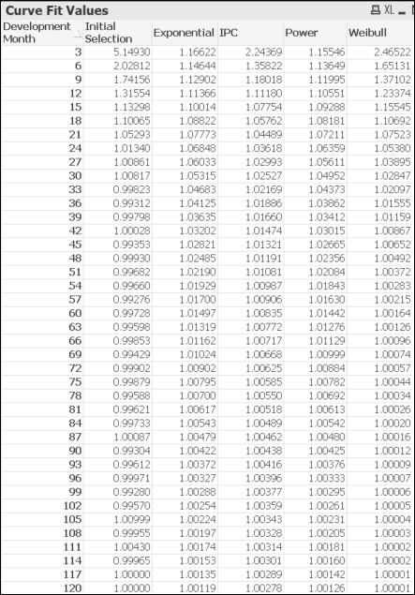
Below is a snapshot of initial selection and the curve fit values for profile ‘Marine_Cargo_DE_CS_AY’

4.Determine the Factor 1 index
- For each development period, proportion of sum of absolute value of incremental incurred for all development periods post that development period to sum of absolute value of incremental incurred for all development periods is calculated.
- The first development period at which the above proportion becomes less than 2% is considered. This development quarter is further referred to as factor_1_index.
- This index is used to determine the development period from which triangle development is to be cut and tail/adjustment factor is to be taken (details on adjustment factor are mentioned in step 9 ahead)
Below is a snapshot of the above calculation for profile ‘Marine_Cargo_DE_CS_AY’ (numbers are in 000’s) The proportion against development quarter 23 (development month 69) is 1.8%. Thus, the factor_1_index =23.
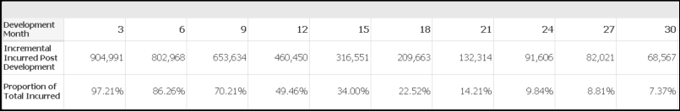

5.Final Selection
- Various sets of pattern selections are made using the algorithm mentioned in detail below. The algorithm iteratively creates combinations of factors using the initial selections and curve fits to create possible sets of factors for final selection. Initial selection is also taken as one of the sets of factors for final selection (this set is considered converged by default).
- An index (referred as default_last_index) is taken for the last development quarter till which the algorithm will be run. By default, this index is taken as 20. The final selection process will belong to one of the 2 possible cases:
- Case 1: If the factor_1_index is less than the default_last_index, the algorithm is run from the first development quarter to the factor_1_index quarter
- Case 2: If the factor_1_index is greater than the default_last_index, then the algorithm is run from the first development quarter to the default_last_index. The development factors for quarters from default_last_index +1 till factor_1_index - 1 are replaced from the curve with the best R-Squared
Algorithm:
- Begin with the initial selection as the base set. The development quarters will range as per one of the 2 cases above.
- Initialize an index replacement tracker which tracks which development quarter of the initial selection is replaced till now. Value for a development quarter can only be replaced once in this algorithm.
- As we go from first development quarter through the last development quarter, check the set for development quarter with value <0.99 or if the value is greater than the value of the previous development quarter.
      - If any such development quarter is found, stop checking the set and mark the current set as ‘not converged’.
      - For all development quarters from the above found quarter through the first, find the development quarter which can be used for replacement using the index replacement tracker. Also, check if the corresponding development quarter’s value from the curve fits are smaller than the previous development quarter’s value in the set.
      - If there exists a valid development quarter in step II above, then mark the development quarter found in step I as ‘replaced’ in the index replacement tracker
      - Repeat the steps b to c above using all the possible curve fits found above.

- As we go from first development quarter through the last development quarter, if all values are decreasing in value and greater than or equal to 0.99, then mark the set as ‘converged’
- Values from development quarter factor_1_index till the last development quarter are taken as 1
Note: Refer to the Appendix 2 for an illustration on the above algorithm.
- Once all possible sets of final selection are created using the algorithm above, the sets are evaluated to choose the best out of the lot. Also, the set of initial selection is always considered as one possible set of final selection and evaluated in this process.
- Algorithm for handling negative developments: Any of the below three conditions need to be satisfied in the initial selections, for incorporating negative development in the pattern selection for a profile
- Five consecutive less than 1 factors
- Decrease in the initial factor from one development to another greater than 5% (Both the factors should be less than 1 in value for this condition)
- Proportion of less than 1 factors more than 40% before the factor 1 index
To incorporate the negative development the model then calculates the index post which it takes the initial selection (as the negative development will be present in the initial selection and not in the curve fit values). The index is calculated basis the minimum index of 1st and 2nd condition mentioned above. Thus, the default_last_index is updated with this index value.
Apart from the assessment of negative developments, the algorithm works the same as mentioned before.

- For each set of selection:
- RMSE is calculated for each development period, between the cumulative percentages and the incurred to ultimate ratios
- Each development period is given weight as absolute of {1 – Incurred % Developed}. Thus, increasing development periods are given decreasing weights and they have lesser data points in them. Initial developments are given more weights because they represent more of the actual experience in data
The set with the least weighted RMSE is chosen as the final selection of LDFs

- Adjustment Factor:
To account for the 2% incurred development left post factor 1 index, an adjustment factor is taken at factor 1 index. Adjustment factor is calculated based on experience – product of initial selected LDF’s post the factor 1 index till the period where the outlier algorithm has run.
Note: In case the final selection algorithm does not allow for <1 factor, and the adjustment factor computes to a factor <1, then MBR will not allow fir <1 factor post factor 1 index too. Adjustment factor will be taken as 1 in this case.
Below is a snapshot of the final selections made as per the algorithm for reserve class ‘Marine_Cargo_DE_CS_AY’. It also shows how the final selected LDFs were selected as per the overall algorithm. Initial selections came out to be the best set for final selection in this case as per the evaluation approach mentioned in point 8 above.
Column ‘Incremental Factors’ are the final selected LDFs selected by the algorithm.
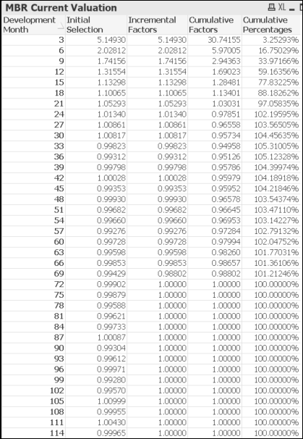
<1 factors were selected from development month 45
Adjustment factor of 0.988 selected at development month 69.
Factor 1 index is development month 69, post which factors are taken as 1
For development month 3 through 42, final selection algorithm ran.

6.Ultimate Calculation
- Relevant previous reserving quarter assumptions are fetched from Vena and checked if they are populated or not.

- LR Ultimate:
- For CY, if Budget LR and BF IELR are different then we consider BF IELR otherwise we consider Budget LR to calculate LR ultimate. (This will ensure that we generally rely on Budget LR at Q2 valuations and BF IELR at Q4 valuations)
- For PY, we take BF IELR to calculate LR ultimate.
- BF Ultimate:
- For CY, if BF IELR from Vena has a non-zero value, then it is taken as the same else it is set to Budget LR
- For PY, it is detrended using the PAI and LTI obtained from Vena
- Cape Cod Ultimate:
- Using the machine based incurred percentage developed, trended developed LR is calculated and subsequently detrended developed LR
- Using the assumptions calculated above and the final MBR selected factors, ultimate is calculated for different reserving methods like chain ladder, BF, LR and Cape Cod.

7.Ultimate Method Selection by Exposure Year
- For CY and the exposure years with MBR selected incurred % developed <= 40%, LR Ultimate is selected.
- For years with incurred % developed >= 85%, DFM Ultimate is selected.
- For rest of the years, we do a hindsight test:
- We exclude oldest 13 years from the hindsight test. For example, for 2021 Q4 valuations we exclude the years from 1997-2009.
(We include recent 12 years from the most recent year having non-zero incurred)
- For hindsight test, we only consider years with incurred % developed > 50%.
- DFM, BF and CC ultimate is calculated using cumulative incurred loss as at the latest development period for that exposure year.
- RMSE is calculated for each method with the DFM Ultimate calculated by MBR.
- Note:
- For years with any high incurred activity or high DFM ULR (selected by MBR), the RMSE approach may be biased towards DFM Ultimate. To correct this, we exclude such years, in case they are outliers.
- Average DFM ULR is calculated from the years with incurred % developed > 50%.
    - An exposure year with DFM ULR outside the range
(0.5* Average DFM ULR, 1.5 Average DFM ULR)
is considered an outlier and is excluded from the RMSE calculation.
- For each exposure year
- If the incurred % developed is between 40% and 50% then the RMSE of BF and CC is calculated and the least RMSE will be selected as MBR selected method.
- If the incurred % developed is between 50% and 85% then the RMSE of BF, CC and DFM is calculated and the least RMSE will be selected as MBR selected method.

Appendix 1

- Root mean squared error (RMSE)
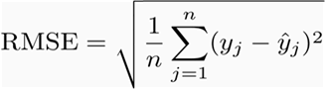

Where y_{j} are the actual values and y_{j}^ are the predicted values

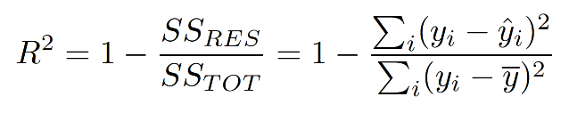
- R-Squared

Where SS_{res} is residual sum of squared errors and SS_{tot} is total sum of squared errors
- Cook's distance

Cook's distance D_{i} of observation i is defined as the sum of all the changes in the model when observation i is removed from it.
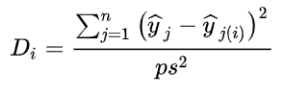
where y_{j(i)}^ is the fitted response value obtained when excluding and s² is the mean squared error of the model.

Appendix 2

Illustration of curve fit replacement in final selection algorithm:
- The algorithm starts with taking the initial selections as the base for making possible sets of factors for final selections.
- Factor at development quarter 7 is greater than factor at development quarter 6 and hence will be replaced from corresponding factors from curve fits.
- This leads to generation of 4 possible sets of factors (refer to Figure 2 below), each made from replacement at development quarter 7 using curve fit factors (with text colour green)
- Factor at development quarter 9 (1.05) is greater than factor at development quarter 8(1.04175) and hence will be replaced from corresponding factors from curve fits (3 factors with text colour green in Figure 1)
- This leads to generation of 12 possible sets of factors (refer to Figure 3 below), each made from replacement at development quarter 9 using curve fit factors.

f

Figure 2: Possible sets of factors post replacement at development quarter 7

Figure 1: Initial Selections and Curve Fits

Figure 3: Possible sets of factors post replacement at development quarter 9

